Entering Paper Survey Responses in Project Outcome
Step 1. Locate the survey you created under the “Survey Management” tab. Click the orange button that says, “Enter Responses”.
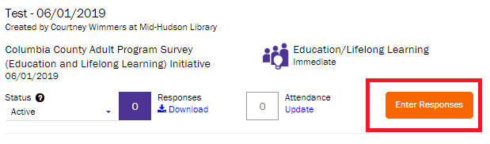

Step 2. There are two way to enter responses. The first is to enter the responses in bulk. Copy the URL in the box on the left to get to the next step. If you want to enter the responses one at a time, click the orange button on the right that says, “Enter Responses Online”.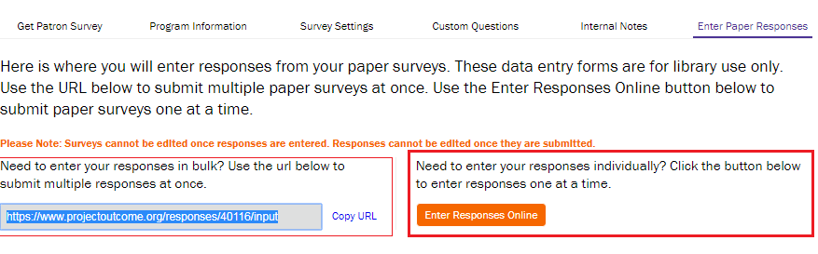
Step 3 (Bulk responses). The bulk entry form link does not require a Project Outcome login, so it can be easily shared with staff or volunteers. The bulk entry form is similar to a spreadsheet. The survey questions appear as headers across the top. Each response will be entered using a new row.
Click the dropdown menu in each column to select the paper survey response for that question.
Type in any open-ended responses in the text boxes below those questions.
To add a new response, click the orange “Add Response” button at the bottom right side of the screen. To submit responses, click the purple “Submit Responses” button. Once you enter responses, they cannot be deleted so be sure to double check your work.
Step 3 (Individual responses). You’ll need to first select a date, and then choose a location from the drop-down list. Then, select the correct response for each question. Type in the responses to the open-ended questions in the text boxes below those questions. If a patron skipped answering a question or did not provide an open-ended response, simply leave that response blank.
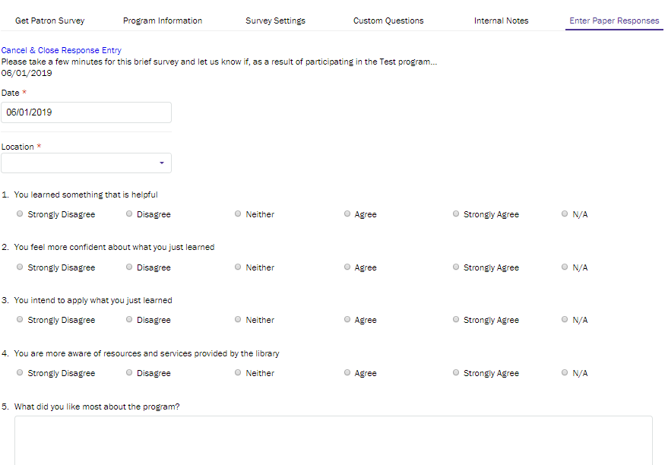
If you have another paper survey to enter, click “Save & Next”. If you are done entering surveys, click “Save & Exit.” Remember that responses cannot be edited once they are submitted. Once your responses are submitted, they will appear in your survey management page.
For assistance, contact either:
· Casey Conlin at cconlin@midhudson.org | 845-471-6060 ext:260
· Courtney Wimmers at cwimmers@midhudson.org | 845-471-6060 ext: 253

