Project Outcome for Columbia County Libraries
1. Create an account:
You will need to make a Project Outcome account if you do not have one already. You can sign up at this link: https://bit.ly/2VNNq8T
2. Find the template in your Survey Management tab:
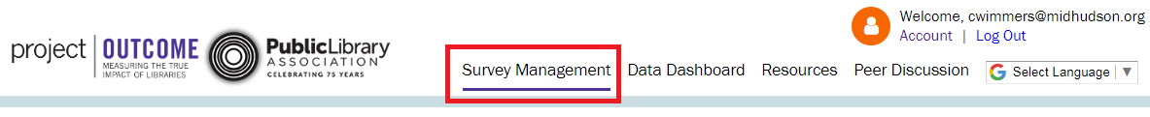
3. Click “Create Survey From Template”.
4. This will open a survey. You do not need to change anything in the first screen. Click the purple arrow on the right to move to the next step.
5. Add your program name, program date, and the location for the respondents. You can choose your library location. You can also add a logo in this area if you wish.

6. Add a survey name. This is your unique survey identifier and will not be visible to respondents.
7. You cannot edit the custom questions in Step 4, and you will skip to Step 5. Here, you can download the survey to print, or get the online survey link.
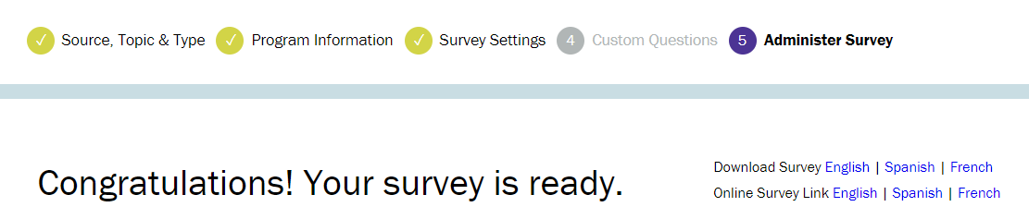
For assistance, contact either:
- Casey Conlin at cconlin@midhudson.org | 845-471-6060 ext:260
- Courtney Wimmers at cwimmers@midhudson.org | 845-471-6060 ext: 253

