Lab project Lists
Total library patrons:
Type: Patron
Field: Home Library
Condition: Starts with
Value A: Your library’s location
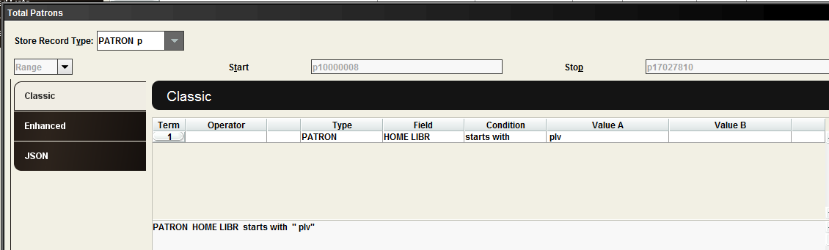

Total library patrons with email:
Type: Patron
Field: Home Library
Condition: Start with
Value A: Your library’s location
AND
Type: Patron
Field: Email Address
Condition: Not equal to
Value A: [Do not enter a value]
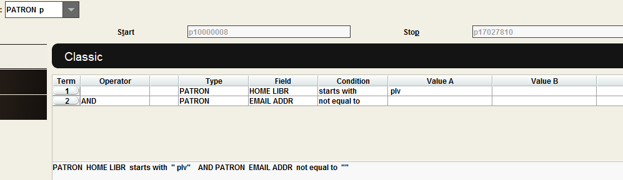

Patrons added each month:
Type: Patron
Field: Home Library
Condition: Starts with
Value A: Your library’s location
AND
Type: Patron
Field: Created
Condition: Between
Value A: Start of the date range you are searching
Value B: End of the date range you are searching

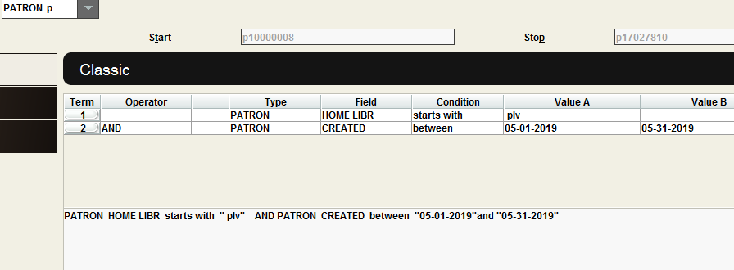

Patron Card Activity – Last Use:
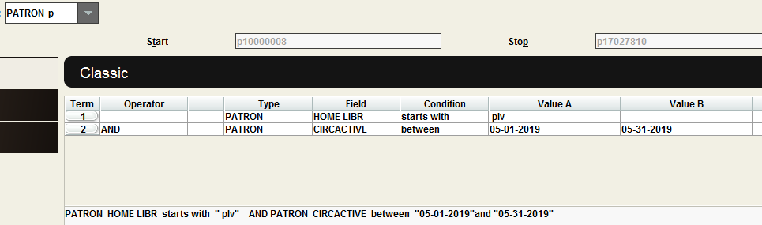

Type: Patron
Field: Home Library
Condition: Starts with
Value A: Your library’s location
AND
Type: Patron
Field: Circ. Active
Condition: Between
Value A: Start of the date range you are searching
Value B: End of the date range you are searching

Number of cardholders that are inactive:
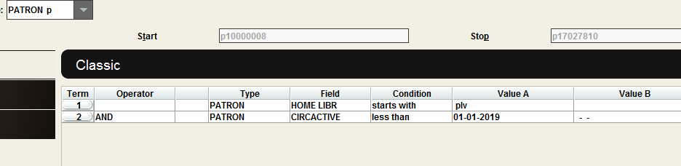
Type: Patron
Field: Home Library
Condition: Starts with
Value A: Your library’s location
AND
Type: Patron
Field: Circ. active
Condition: Less than
Value A: [Date – In this case, we are looking for everyone that hasn’t used their card since January 1, 2019]

