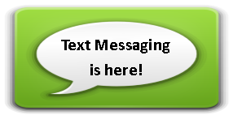
Do you want to get your library notifications by text? Opt In Today!  - Login to your library account from midhudsonlibraries.org  - Select My Account from the top left.  - Choose Edit account  - Enter your mobile number  - Check the box to Opt in  - Click SUBMIT to save the Change.  - A text will arrive soon asking you to “reply YES” to confirm that you wish to receive texts from the library. | Do you want to get your library notifications by text? Opt In Today!  - Login to your library account from midhudsonlibraries.org  - Select My Account from the top left.  - Choose Edit account  - Enter your mobile number  - Check the box to Opt in  - Click SUBMIT to save the Change.  - A text will arrive soon asking you to “reply YES” to confirm that you wish to receive texts from the library. | Do you want to get your library notifications by text? Opt In Today!  - Login to your library account from midhudsonlibraries.org  - Select My Account from the top left.  - Choose Edit account  - Enter your mobile number  - Check the box to Opt in  - Click SUBMIT to save the Change.  - A text will arrive soon asking you to “reply YES” to confirm that you wish to receive texts from the library.

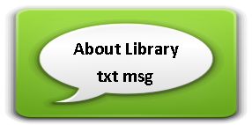

- The text is automated—sorry you won’t reach us with a reply  - The text notice is in addition to the regular notification, so we still send the email or phone message.  - You will get message for each  ◊ Item to pick up  ◊ Item soon due or renewed  ◊ Item overdue  - Terms and Conditions  midhudsonlibraries.org/sms_terms.html  - Login to your library account from midhudsonlibraries.org to opt out at anytime. You can also reply STOP from device. | - The text is automated—sorry you won’t reach us with a reply  - The text notice is in addition to the regular notification, so we still send the email or phone message.  - You will get message for each  ◊ Item to pick up  ◊ Item soon due or renewed  ◊ Item overdue  - Terms and Conditions  midhudsonlibraries.org/sms_terms.html  - Login to your library account from midhudsonlibraries.org to opt out at anytime. You can also reply STOP from device. | - The text is automated—sorry you won’t reach us with a reply  - The text notice is in addition to the regular notification, so we still send the email or phone message.  - You will get message for each  ◊ Item to pick up  ◊ Item soon due or renewed  ◊ Item overdue  - Terms and Conditions  midhudsonlibraries.org/sms_terms.html  - Login to your library account from midhudsonlibraries.org to opt out at anytime. You can also reply STOP from device.

